

**Group members**

* ALMAS BIBI (004)
* ADEEL YAQOOB (001)

**SUBJECT**

* COMPUTER PROGRAMMING

**SUBMITTED TO**

* SIR SOHAIL MUHAMMAD

DEPARTMENT OF COMPUTER SCIENCE

**Report on Rock, Paper,**

**Scissors Game**

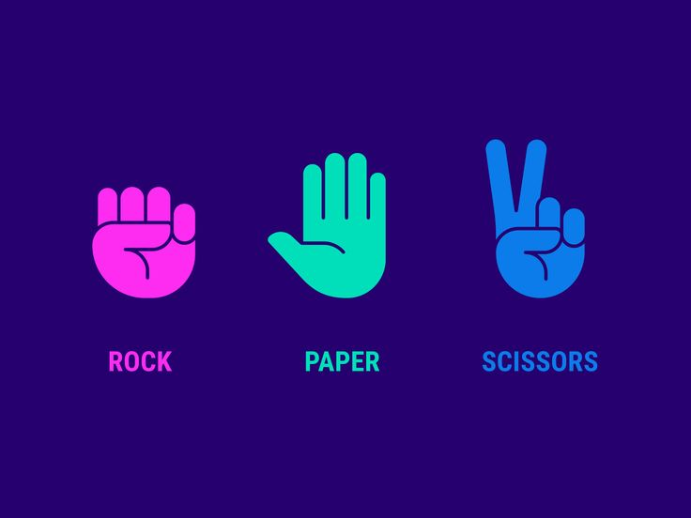

**Report Title:**

Exploring C++: Rock, Paper, Scissors Game

# **Members:**

* Almas Bibi
* Adeel Yaqoob

# **Code:**

#include <iostream>

#include <cstdlib> // For rand() and srand() functions

#include <ctime> // For time() function

using namespace std;

// Function to print the choices

void printChoices(char playerChoice, char computerChoice) {

cout << "You chose: " << playerChoice << endl;

cout << "Computer chose: " << computerChoice << endl;

}

// Function to determine the winner of a single round

// Returns 1 if player wins, -1 if computer wins, 0 for a tie

int determineRoundWinner(char playerChoice, char computerChoice) {

if (playerChoice == computerChoice) {

return 0; // Tie

}

else if ((playerChoice == 'r' && computerChoice == 's') ||

(playerChoice == 'p' && computerChoice == 'r') ||

(playerChoice == 's' && computerChoice == 'p')) {

return 1; // Player wins

}

else {

return -1; // Computer wins

}

}

int main() {

srand(time(NULL)); // Seed the random number generator with current time

int numRounds;

cout << "How many rounds do you want to play? ";

cin >> numRounds;

int playerScore = 0;

int computerScore = 0;

for (int round = 1; round <= numRounds; ++round) {

cout << "\nRound " << round << endl;

// Prompt player for choice

char playerChoice;

cout << "Enter your choice (r for Rock, p for Paper, s for Scissors): ";

cin >> playerChoice;

// Generate computer's choice randomly

char choices[] = { 'r', 'p', 's' };

char computerChoice = choices[rand() % 3];

// Print choices

printChoices(playerChoice, computerChoice);

// Determine the winner of the round

int roundResult = determineRoundWinner(playerChoice, computerChoice);

if (roundResult == 1) {

cout << "You win this round!" << endl;

playerScore++;

}

else if (roundResult == -1) {

cout << "Computer wins this round!" << endl;

computerScore++;

}

else {

cout << "It's a tie!" << endl;

}

}

// Display overall results

cout << "\nGame over! Results:" << endl;

cout << "Player score: " << playerScore << endl;

cout << "Computer score: " << computerScore << endl;

if (playerScore > computerScore) {

cout << "Congratulations! You win the game!" << endl;

}

else if (computerScore > playerScore) {

cout << "Computer wins the game. Better luck next time!" << endl;

}

else {

cout << "It's a tie game!" << endl;

}

return 0;

}

# **Output:**

How many rounds do you want to play? 3

**Round 1**

Enter your choice (r for Rock, p for Paper, s for Scissors): r

You chose: r

Computer chose: s

You win this round!

**Round 2**

Enter your choice (r for Rock, p for Paper, s for Scissors): s

You chose: s

Computer chose: p

You win this round!

**Round 3**

Enter your choice (r for Rock, p for Paper, s for Scissors): p

You chose: p

Computer chose: p

It's a tie!

Game over! Results:

Player score: 2

Computer score: 0

**Congratulations! You win the game!**